root@cyberster:~$
DAY 07 / DASHBOARD NAVIGATION & ALERT TRIAGE
Wazuh SOC Lab · Cyberster Internship, Phase One
// 01 OBJECTIVE
Six days were spent building the lab. Today was the first day spent using it. The goal shifted from installation to interpretation: spending real time inside the Security Alerts view, learning to read an alert's detail panel, practicing Threat Hunting queries, reviewing the MITRE ATT&CK mapping, and starting to build a sense of what “normal” looks like in this environment so future alerts can be judged against a baseline rather than read in isolation.
- Spend a full hour inside Security Alerts, reading individual alerts rather than scrolling past them
- Understand the 0–15 rule level scale and what each band actually implies
- Practice filtering in Threat Hunting by agent, time, level, and field
- Review how alerts map to MITRE ATT&CK and understand why that mapping matters
- Identify the ten most frequent alert types and judge each as genuine concern or routine activity
// 02 SECURITY ALERTS — ONE HOUR REVIEW
Worked through the Security Alerts view sorted by most recent first, opening individual alerts rather than skimming the list. For each one opened, the same three questions were asked: which agent generated it, which rule matched, and whether the assigned rule level matched how serious the activity actually looked.
The biggest early lesson: the large majority of alerts firing in this lab are not attacks. They are the environment doing exactly what was configured — scheduled SCA scans, rootcheck heuristics flagging normal Kali behavior, syscheck noticing files that changed during setup work, and housekeeping logs like dpkg.log and the df -P disk check from Day 5–6. Recognising that noise for what it is, quickly and confidently, is the actual skill being built this week — not just generating alerts, but knowing which ones deserve a second look.
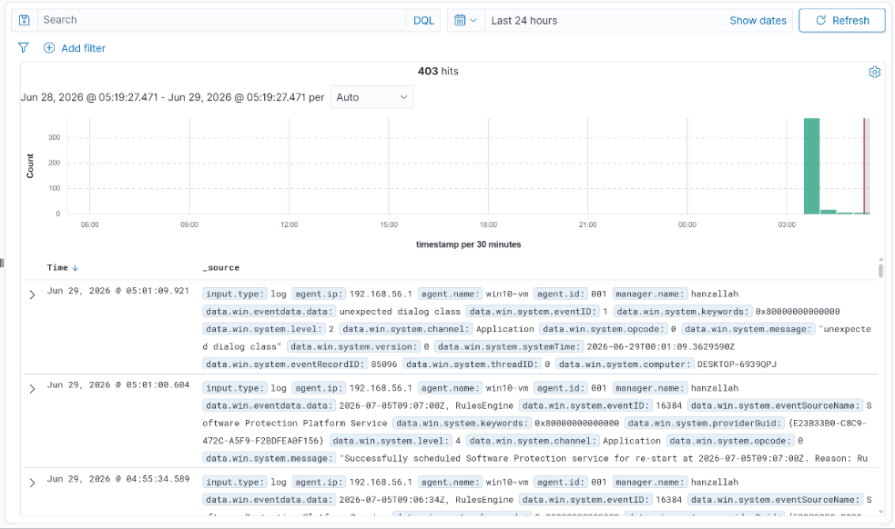
Security Alerts view — general list, sorted by time, showing a mix of alert levels
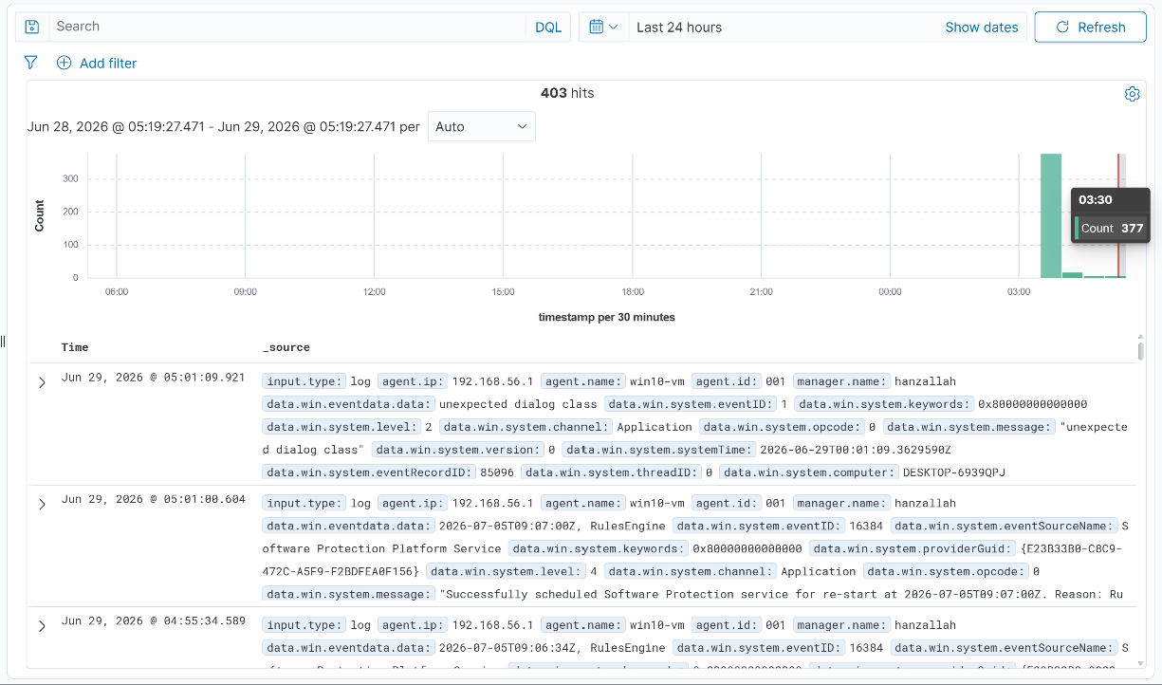
An individual alert detail panel expanded, showing agent / rule / data fields
// 03 UNDERSTANDING RULE LEVELS
Wazuh rule levels run from 0 to 15. The number alone does not say whether something is actually dangerous — it says where to look first. A level 3 alert that is part of a pattern can matter more than an isolated level 9. Used as a triage starting point, not a final verdict, the scale breaks down as follows:
Level Range | Meaning
0 – 3 | Informational — no action needed by default
4 – 7 | Low severity — worth noting, rarely worth acting on alone
8 – 11 | Medium — worth opening and reading the detail panel
12 – 15 | High / Critical — needs immediate attention
// 04 THREAT HUNTING — QUERY PRACTICE
Practiced building filters in the Threat Hunting module, starting from a single field and layering in more conditions. The syntax used field:value pairs, range queries, and boolean AND, building up from a simple agent filter to a combined query across agent and severity.
$ Queries Practiced
agent.name:kali-vm
rule.level>=8
rule.level:[8 TO 11]
agent.name:hanzallah AND rule.level>=7
data.srcip:192.168.56.102
Applied a three-filter combination — manager.name, rule.level (7 to 11), and agent.name (kali-vm) — to narrow a full day of activity down to 31 relevant hits. Within that filtered set, the two clearest repeating alert types were an SCA policy summary (Unix system audit, level 9) and a rootcheck alert for hidden files inside /root (level 7).
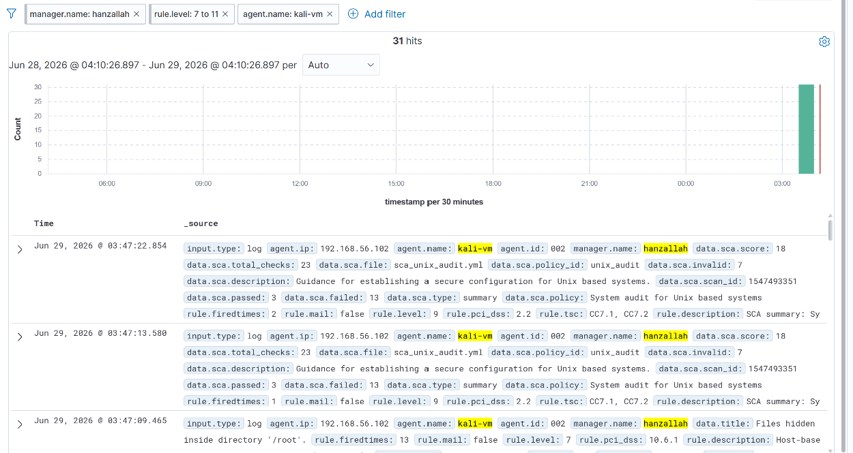
Threat Hunting — manager.name + rule.level:[7 TO 11] + agent.name:kali-vm — 31 hits over 24 hours
This is the practical value of the module: instead of scrolling through every alert from every agent, a three-field filter isolates exactly the slice worth reviewing in under a minute.
// 05 MITRE ATT&CK REVIEW
MITRE ATT&CK is the industry-standard taxonomy for categorising attacker behaviour. Instead of every analyst or tool describing an event in its own words, ATT&CK gives everyone the same vocabulary — a repeated failed login is universally “T1110, Brute Force,” regardless of which SIEM produced the alert. That shared language is what makes it possible to compare incidents across tools, write detections that mean the same thing everywhere, and communicate findings to people outside the immediate team without losing precision.
$ Scoped to kali-vm
Filtering the MITRE module down to alerts where rule.mitre.id exists, scoped to the Kali agent, surfaced four tactics: Defense Evasion, Privilege Escalation, Initial Access, and Persistence — broken down into specific techniques including Valid Accounts, Rootkit, Disable or Modify Tool, and Sudo and Sudo Caching.
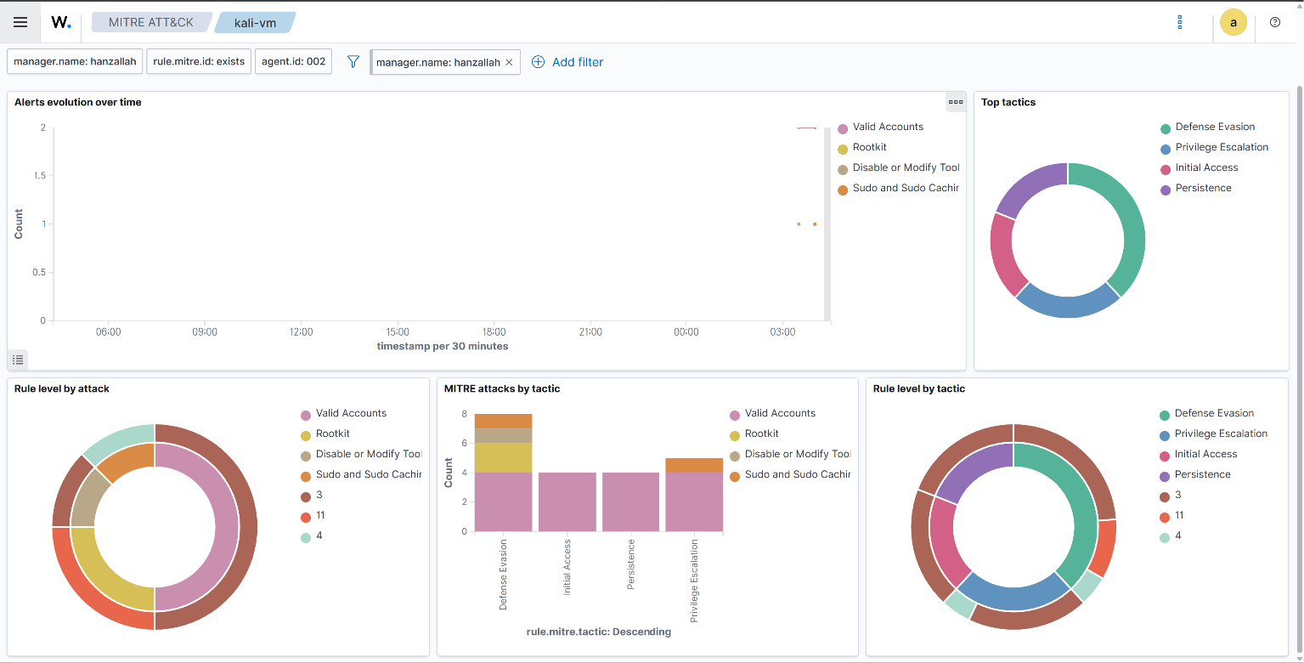
MITRE ATT&CK — kali-vm, rule.mitre.id:exists — tactic and technique breakdown
$ Full Environment View
Removing the agent filter and looking across all three endpoints (hanzallah, kali-vm, win10-vm) added two more tactics — Credential Access and Lateral Movement — and two more techniques tied to the Day 5–6 SSH test: Password Guessing and SSH, alongside Brute Force. Valid Accounts remained the single largest technique bucket across every agent and tactic.
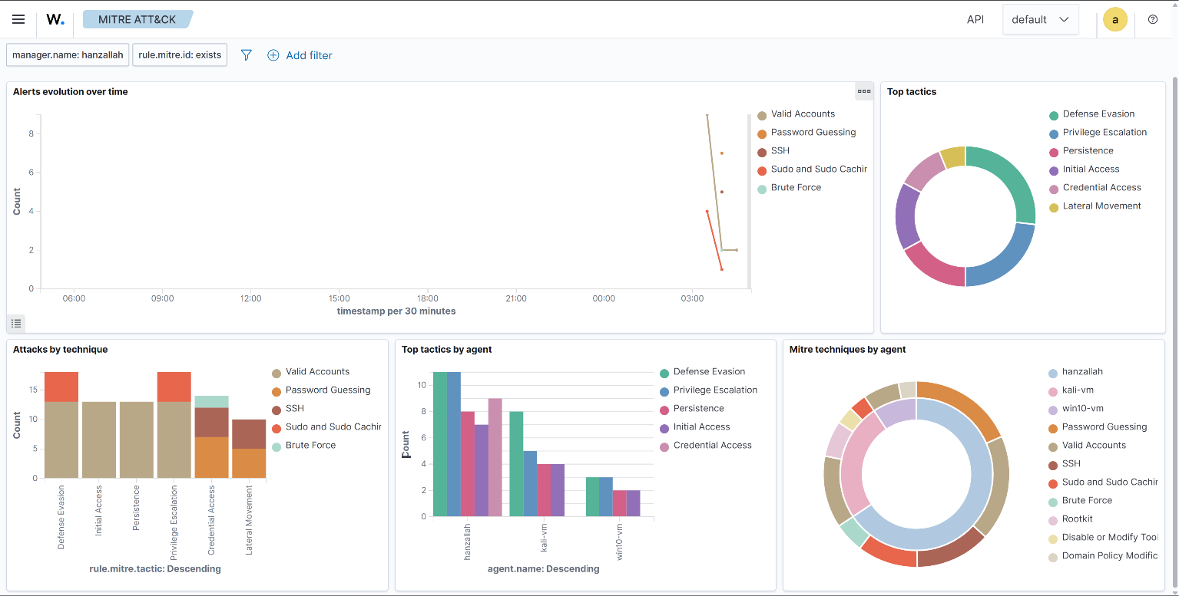
MITRE ATT&CK — full environment, rule.mitre.id:exists — all three agents
The dominance of Valid Accounts across all three agents is itself a useful baseline signal: it tracks almost exactly with normal sudo and login activity during a week of hands-on lab work, not credential misuse. That is the kind of pattern that becomes obvious once a baseline exists — and invisible without one.
// 06 TOP 10 ALERT TYPES — TRIAGE ASSESSMENT
The ten alert types below were the most frequently observed across the Security Alerts review, the filtered Threat Hunting queries, and the MITRE ATT&CK breakdowns. Rule IDs are marked for verification where the exact numeric ID was not directly visible in a screenshot — the rule.level, description, and MITRE mapping shown are taken directly from the dashboard.
$ 1. SCA Policy Summary — Unix Audit
Field | Value
Rule ID | ~19002 range — verify in alert detail
Rule Level | 9
Trigger | Scheduled Security Configuration Assessment scan against sca_unix_audit.yml; 23 checks run, 13 failed
Assessment | Routine. Fires on a schedule, not in response to an event. The failed checks are real hardening gaps worth a one-time review, but the recurring alert itself is not a security incident.
$ 2. Rootcheck — Hidden Files Inside /root
Field | Value
Rule ID | ~533 range — verify in alert detail
Rule Level | 7
Trigger | Rootcheck module flags files carrying the hidden attribute inside /root
Assessment | Likely routine on Kali — pentesting tools and shell configs commonly create dotfiles in home directories. Worth a one-time manual check, not itself evidence of compromise on a single-user lab VM.
$ 3. SSH Authentication Failure / Brute Force (T1110)
Field | Value
Rule ID | ~5760 range — verify in alert detail
Rule Level | 10
Trigger | Repeated failed SSH logins detected in auth.log (self-generated test from Day 5–6)
Assessment | Genuine concern as a category — this exact alert type should never be dismissed as noise in a real environment, even though here it was a deliberate, known test rather than an actual attacker.
$ 4. Valid Accounts (T1078)
Field | Value
Rule ID | Varies by underlying matched rule — verify in alert detail
Rule Level | Spans 3–11 depending on the specific action
Trigger | Authenticated login, su, or sudo activity — tagged under this technique because it covers both legitimate use and attacker misuse of valid credentials
Assessment | Mostly routine. The single largest technique bucket across all three agents, which tracks with constant normal login and sudo activity during a week of setup work, not credential misuse.
$ 5. Sudo and Sudo Caching
Field | Value
Rule ID | Rootcheck-related — verify in alert detail
Rule Level | Low–medium (3–4 band observed)
Trigger | Rootcheck/syscheck noticing sudo's credential caching behaviour during a session
Assessment | Routine. Standard sudo behaviour on any Linux system using sudo repeatedly in one session; a common hardening note, not malicious activity.

$ 6. Rootkit Detection
Field | Value
Rule ID | Rootcheck 5xx range — verify in alert detail
Rule Level | Medium (~4 band observed)
Trigger | Rootcheck signature-matching scan against known rootkit indicators
Assessment | Worth confirming once, but on a fresh Kali VM with no internet-facing exposure this is almost certainly a false positive from rootcheck's broad heuristics rather than an actual rootkit.
$ 7. Disable or Modify Tool (T1562)
Field | Value
Rule ID | Verify in alert detail
Rule Level | Medium
Trigger | A change to or disabling of a security-relevant tool or service was detected
Assessment | Deserves a second look rather than an automatic dismissal — this technique specifically covers defense-evasion behaviour such as disabling logging. Plausible as routine config work here, but not a category to wave through without checking what was actually touched.
$ 8. Domain Policy Modification
Field | Value
Rule ID | Verify in alert detail
Rule Level | Low (small slice in the MITRE breakdown)
Trigger | A change to a system policy setting was recorded
Assessment | Low volume, likely tied to one-off configuration changes made during VM setup earlier in the week. Worth noting but not concerning given how rarely it fired.
$ 9. File Integrity (Syscheck) Baseline Changes
Field | Value
Rule ID | 550–553 range — verify in alert detail
Rule Level | 7
Trigger | Syscheck detects a file under a watched directory (/etc, /bin, /usr/bin, etc.) that differs from its recorded baseline
Assessment | Expected during the first days after agent install while Wazuh is still establishing what “normal” looks like. Worth re-checking once the agent has run a full week without active configuration changes.

$ 10. System / Package Housekeeping
Field | Value
Rule ID | Generic command-output / log rules — verify in alert detail
Rule Level | 0–3 (informational)
Trigger | Routine logging from active-responses.log, dpkg.log, and the scheduled df -P disk-space check configured on Day 5–6
Assessment | Pure noise from a security standpoint — useful for system health, but this is the category that should be filtered out of any active triage queue first.
// 07 KEY TAKEAWAYS
- Most of what appears in a SOC dashboard on any given day is not an attack — it is the environment behaving as configured. Recognising that quickly, without dismissing the genuinely odd alerts, is the core skill being built.
- Rule level is a starting point for attention, not a verdict — a low-level alert that repeats in a pattern can matter more than an isolated medium one.
- A three-field Threat Hunting query (agent, time, level) turns a full day of noise into a handful of relevant hits in seconds — far faster than scrolling.
- MITRE ATT&CK mapping turns an isolated log line into a named, comparable technique — the same alert means the same thing whether read here or in a different SOC entirely.
- Valid Accounts dominating the technique breakdown across every agent is itself the first real baseline signal from this environment — a pattern that only becomes visible after deliberately looking for one.

// 08 WEEK 1 — CONCLUSION
In seven days the lab went from nothing to a working SOC: three endpoints (Kali, Ubuntu Server, and the Windows 11 host) reporting into a single Wazuh Manager, with agents, file integrity monitoring, and log collection all confirmed live. A real attack technique — SSH brute force — was generated, detected, alerted on, and correctly mapped to MITRE ATT&CK end to end, proving the pipeline works rather than just assuming it does.
The shift in the second half of the week mattered more than the installs: moving from “does the agent show Active” to “what is this alert actually telling me, and does it deserve attention.” Reviewing alerts for an hour, building Threat Hunting queries from scratch, and judging ten real alert types on their merits rather than their rule level alone is the first real rep of the skill the rest of this internship is going to keep building on.
Heading into Week 2 with a working environment and an early baseline — Valid Accounts and routine system housekeeping as the dominant “normal,” SSH brute force as the one confirmed real technique — gives a concrete starting point rather than a blank dashboard.

